

AP® Physics C
1980 Free Response Questions

The materials included in these files are intended for use by AP teachers for course and exam preparation in the classroom; permission for any other use must be sought from the Advanced Placement Program®. Teachers may reproduce them, in whole or in part, in limited quantities, for face-to-face teaching purposes but may not mass distribute the materials, electronically or otherwise. These materials and any copies made of them may not be resold, and the copyright notices must be retained as they appear here. This permission does not apply to any third-party copyrights contained herein.

These materials were produced by Educational Testing Service® (ETS®), which develops and administers the examinations of the Advanced Placement
Program for the College Board. The College Board and Educational Testing Service (ETS) are dedicated to the principle of equal opportunity, and their
programs, services, and employment policies are guided by that principle.

The College Board is a national nonprofit membership association dedicated to preparing, inspiring, and connecting students to college and opportunity.
Founded in 1900, the association is composed of more than 4,200 schools, colleges, universities, and other educational organizations. Each year, the
College Board serves over three million students and their parents, 22,000 high schools, and 3,500 colleges, through major programs and services in
college admission, guidance, assessment, financial aid, enrollment, and teaching and learning. Among its best-known programs are the SAT®, the
PSAT/NMSQT®, and the Advanced Placement Program® (AP®). The College Board is committed to the principles of equity and
excellence, and that commitment is embodied in all of its programs, services, activities, and concerns.

APIEL is a trademark owned by the College Entrance Examination Board. PSAT/NMSQT is a registered trademark jointly owned by the College Entrance Examination Board and the National Merit Scholarship Corporation. Educational Testing Service and ETS are registered trademarks of Educational Testing Service.

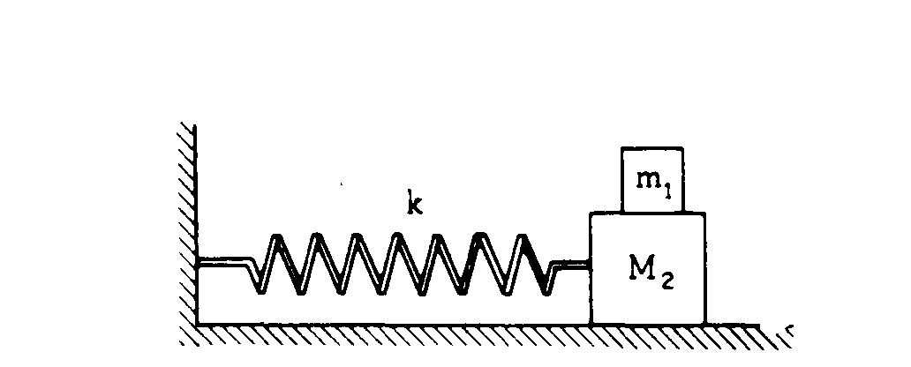
1980M1. A small mass m₁ rests on but is not attached to a large mass M₂ that slides on its base without friction.
The maximum frictional force between m₁ and M₂ is f. A spring of spring constant k is attached to the
large mass M₂ and to the wall as shown above.
a. Determine the maximum horizontal acceleration that M₂ may have without causing m₁ to slip.
b. Determine the maximum amplitude A for simple harmonic motion of the two masses if they are to move together, i.e., m₁ must not slip on M₂.
c. The two-mass combination is pulled to the right the maximum amplitude A found in part (b) and released. Describe the frictional force on the small mass m₁ during the first half cycle of oscillation.
d. The two-mass combination is now pulled to the right a distance of A' greater than A and released.
i. Determine the acceleration of m₁ at the instant the masses are released.
ii. Determine the acceleration of M₂ at the instant the masses are released.

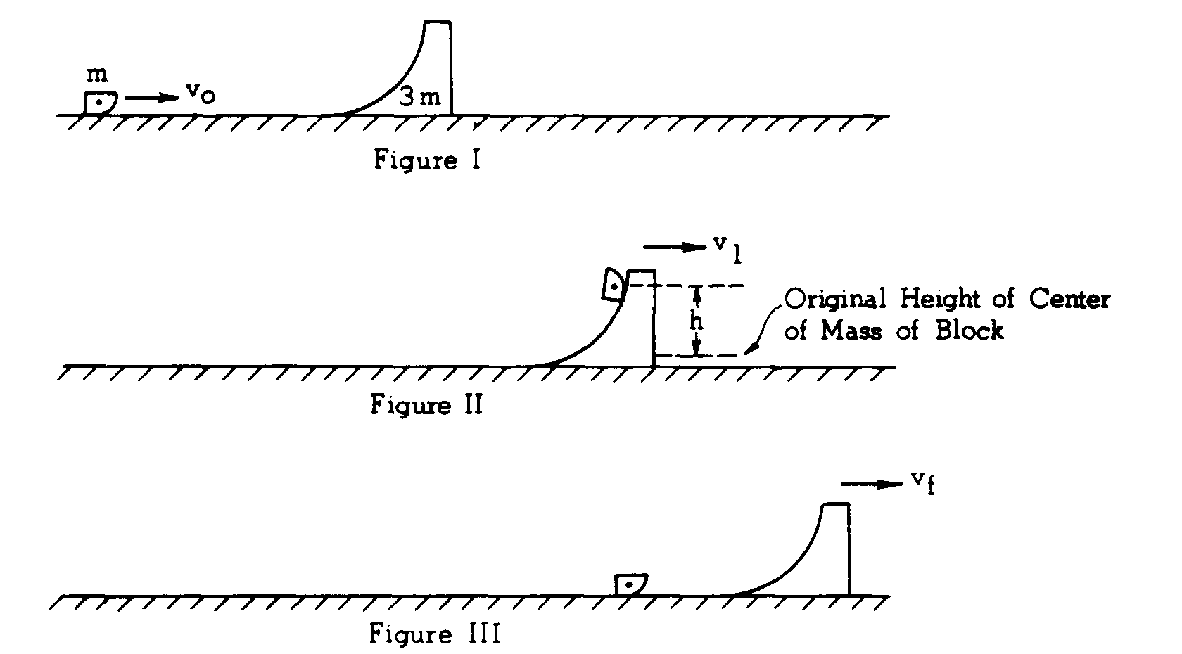
1980M2. A block of mass m slides at velocity v_{o} across a horizontal frictionless surface toward a large curved movable ramp of mass 3m as shown in Figure 1. The ramp, initially at rest, also can move without friction and has a smooth circular frictionless face up which the block can easily slide. When the block slides up the ramp, it momentarily reaches a maximum height as shown in Figure II and then slides back down the frictionless face to the horizontal surface as shown in Figure III.
a. Find the velocity v₁ of the moving ramp at the instant the block reaches its maximum height.
b. To what maximum height h does the center of mass of the block rise above its original height?
c. Determine the final speed v_{f} of the ramp and the final speed v' of the block after the block returns to the level surface. State whether the block is moving to the right or to the left.
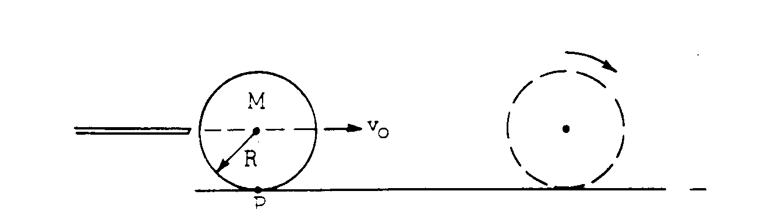
1980M3. A billiard ball has mass M, radius R, and moment of inertia about the center of mass I_{c} = 2 MR²/5
The ball is struck by a cue stick along a horizontal line through the ball's center of mass so that the ball initially slides with a velocity v_{o} as shown above. As the ball moves across the rough billiard table (coefficient of sliding friction μ_{k}), its motion gradually changes from pure translation through rolling with slipping to rolling without slipping.
a. Develop an expression for the linear velocity v of the center of the ball as a function of time while it is rolling with slipping.
b. Develop an expression for the angular velocity ω of the ball as a function of time while it is rolling with slipping.
c. Determine the time at which the ball begins to roll without slipping.
d. When the ball is struck it acquires an angular momentum about the fixed point P on the surface of the table. During the subsequent motion the angular momentum about point P remains constant despite the frictional force. Explain why this is so.

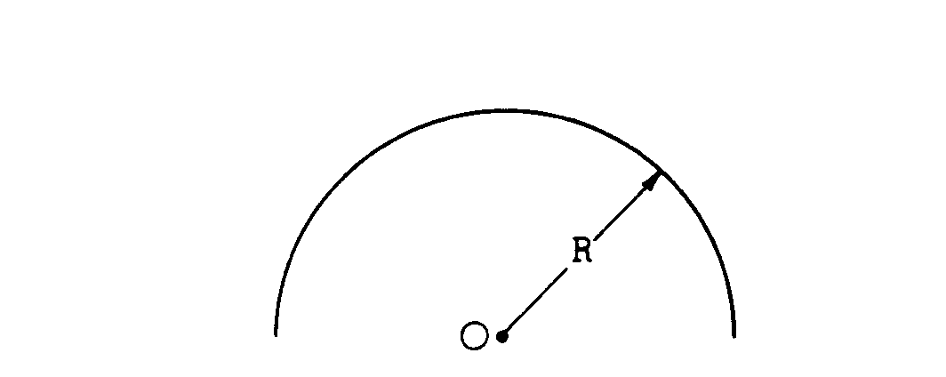
1980E1. A thin plastic rod has uniform linear positive-charge density λ. The rod is bent into a semicircle of radius R as shown above.
a. Determine the electric potential V_{o} at point 0, the center of the semicircle.
b. Indicate on the diagram above the direction of the electric field at point 0. Explain your reasoning.
c. Calculate the magnitude E_{o} of the electric field at point 0.
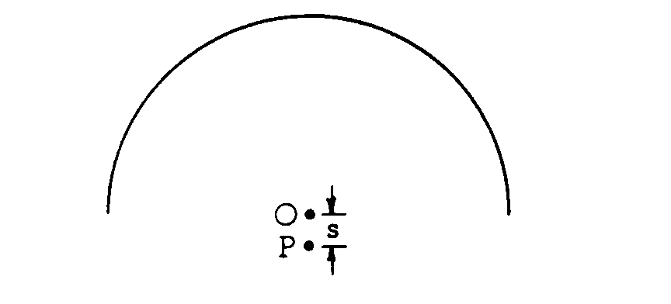
d. Write an approximate expression, in terms of q, V_{o}, and E_{o}, for the work required to bring a positive point charge q from infinity to point P, located a small distance s from point O as shown in the diagram above.
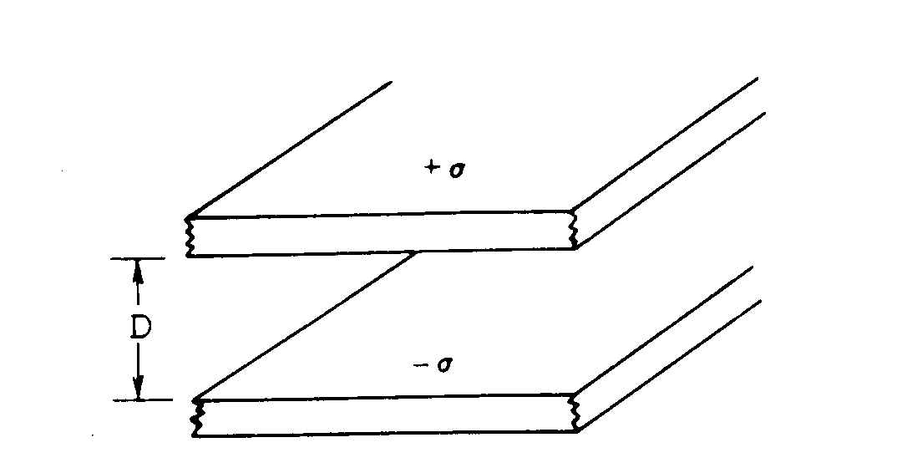

1980E2. A parallel-plate capacitor consists of two conducting plates separated by a distance D as shown above. The plates may be considered very large so that the effects of the edges may be ignored. The two plates have an equal but opposite surface charge per unit area, σ. The charge on either plate resides entirely on the inner surface facing the opposite plate.
a. On the diagram below draw the electric field lines in the region between the plates.
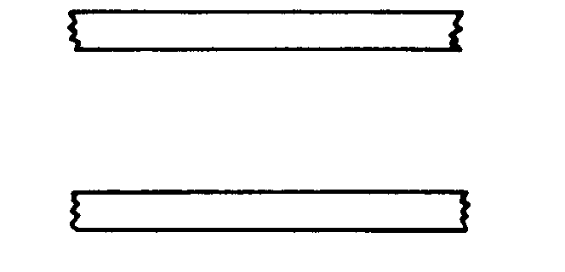

b. By applying Gauss's law to the rectangular box whose upper surface lies entirely within the top conducting plate, as shown in the following diagram, determine the magnitude of the electric field E
in the region between the plates.
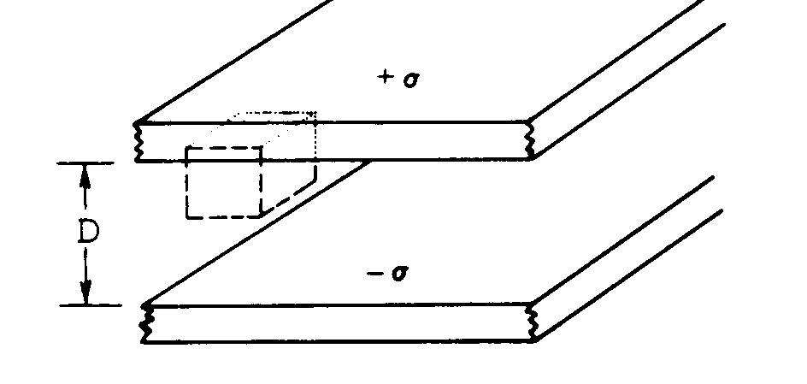

c. A dielectric is inserted and fills the region between the plates. Is the electric field greater than, less than, or equal to the electric field when there is no dielectric? Describe the mechanism responsible for this effect. Recognize that the plates are not connected to a battery.

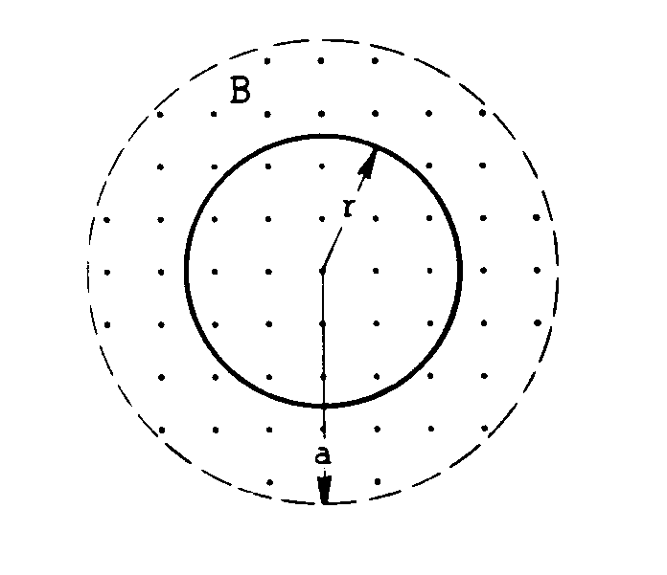
1980E3. A spatially uniform magnetic field directed out of the page is confined to a cylindrical region of space of radius a as shown above. The strength of the magnetic field increases at a constant rate such that
B = B_{o} + Ct, where B_{o} and C are constants and t is time. A circular conducting loop of radius r and resistance R is placed perpendicular to the magnetic field.
a. Indicate on the diagram above the direction of the induced current in the loop. Explain your choice.
b. Derive an expression for the induced current in the loop.
c. Derive an expression for the magnitude of the induced electric field at any radius r < a.
d. Derive an expression for the magnitude of the induced electric field at any radius r > a.

